Hands-on lab: Registering your company and offer

# Goal

The goal of this hands-on lab is to have the reader register their company, tax information and offers with Azure Store. Once this information is submitted, a Windows Azure engineer will approve it so it will show up in the Windows Azure Store UI. Additionally, it will allow your Resource Provider (RP) to be tested.

# Detailed Steps

## Register your company

1. Log into the Publishing Portal  
   <https://publish.marketplace.windowsazure.com/>
2. 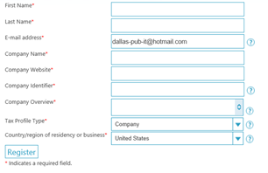Create a **Publisher** account
   1. **First Name –** The first name of the account owner. This should be the person to whom payments will be made.
   2. **Last Name –** The first name of the account owner. This should be the person to whom payments will be made.
   3. **E-Mail Address** – the email address of the account owner
   4. **Company Name** – the legal name of your company
   5. **Company Website**
   6. **Company Identifier –** This is the *resource provider namespace* used to identify your offer in URLs. Should be similar to Company Name. For example, the Bing Search API uses Bing as the identifier.
   7. **Company Overview –** Brief overview of your business
   8. **Tax Profile –** Are you acting on behalf of an individual [yourself] or a corporation?
   9. **Country or Region –** the country or region in which you are doing business, whose currency you wish to use, and where you will be paying taxes.

## Create offers

1. Click on the **Publish** tab



1. 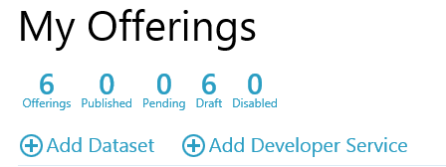Click on **Add Developer Service**
2. Provide your **Resource Manifest**. The contents of the Resource Manifest are described in the Resource Provider API document.

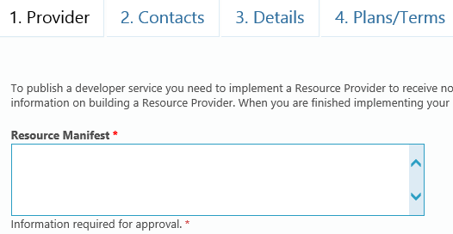

1. Provide **Support Contact** and **Business Contact**. This information will be used by the Marketplace team to address any integration or business issues with your organization.

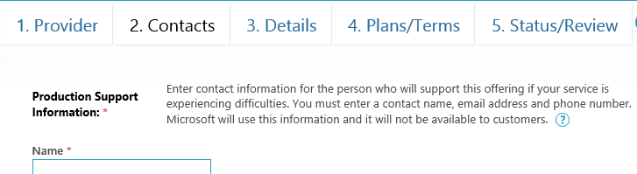

1. Provide **Offer Details** for your Service

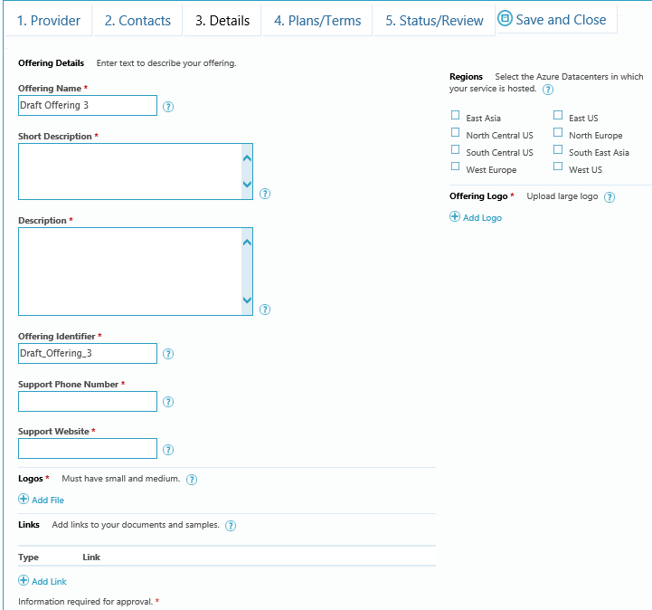

* **Offering Name** – the name of the Service
* **Short Description –** description used in search results
* **Long Description –** description used in detail views
* **Offering Identifier** – Used to identify your offer in URLs. Should be similar to Offering Name. This is also the *resource type* that your provider supports. For example, the Bing Search API uses Search as the identifier.
* **Support Phone Number** – displayed to users for assistance with the service
* **Support Website** – displayed to users for assistance with the service
* **Logos** – Upload a small and medium logo for your offer. Hover over the ‘?’ icon for sizes. **Links –** Links to resources that will help users understand and use your service. Documentation, for example.
* **Regions –** The Azure Datacenters in which your service is available. If you are hosted outside of Azure do not check any of these options.
* **Offering Logo –** The large logo for your offering.

1. 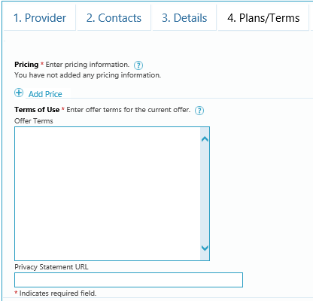Provide **Terms of Use**  and **Privacy Statement** for your Service  
   1. **Terms of Use** – text of your Terms of Use. Users will be required to accept these before subscribing.
   2. **Privacy Statement URL** – URL to your Terms of Use

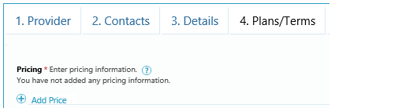

1. Provide **Terms of Use**  and **Privacy Statement** for your Service
   1. Determine how many plans you want to provide. For example, you can provide
      1. Bronze for $10.00 / month
      2. Silver for $20.00 / month
      3. Gold for $200.00 / month
   2. For each Plan:
      1. Click the **Add Price** button on the **Plans/Terms** tab
      2. Provide **Plan Information**  
         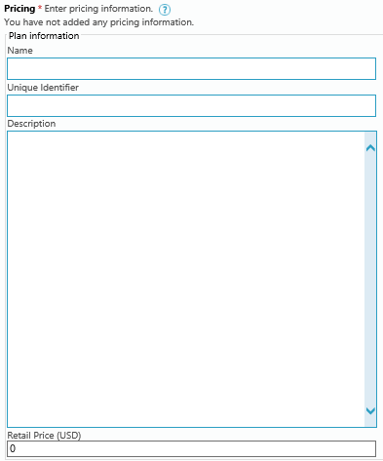
2. **Name** – The name of the Plan, e.g. **Silver**
3. **Unique Identifier –** The ID passed to your provisioning API during subscription management operations. You will include this string in the configuration of your Resource Provider.
   * + 1. **Description –** the plan description that will be shown to potential subscribers
       2. **Retail Price –** the price you want to charge for this plan. The currency will default to the currency for your publisher account and automatically converted to the purchasing currency of your buyers.
       3. **Markets** – select the markets to which you wish to sell your service. Typically you will want to select All Markets.
       4. **Save and Close**
4. **Submit** your service on the **Status/Review** tab. If you are missing any required content it will be called out for you here.